NHS Bursary – social media example posts for current students

2024/25

General messages
Facebook | Have you heard about the NHS Bursary?  It provides funding for eligible medical or dental students who normally live in England.  You could get:  🔹a tuition fee contribution  🔹a non-means tested bursary  🔹a means tested bursary based on your household income  🔹additional allowances depending on your circumstances  Find out more 👉 https://www.nhsbsa.nhs.uk/nhs-bursary | 

X | Have you heard about the NHS Bursary? 🧑‍⚕️  Eligible medical and dental students could get a tuition fee contribution, means and non-means tested grants, and additional allowances depending on your circumstances.  Learn more 👉 https://www.nhsbsa.nhs.uk/nhs-bursary | 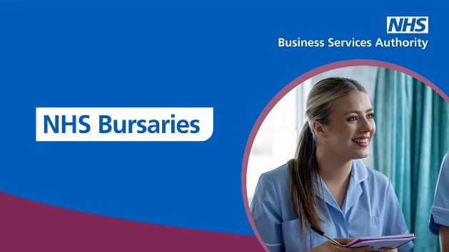
Facebook | The NHS Bursary is here for you, because you’re there for us 💙  If you’re studying to become a doctor or dentist, you could be eligible for extra support to help you through your university journey.  For full details, check out the NHSBSA website 👉 https://www.nhsbsa.nhs.uk/nhs-bursary | 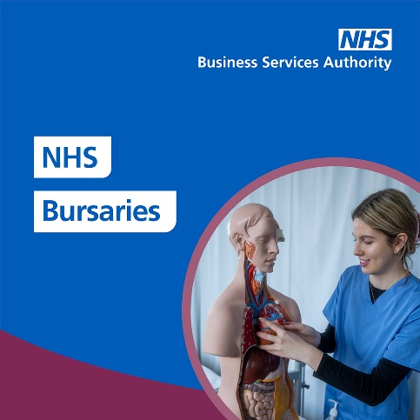

X | The NHS Bursary is here for you, because you’re there for us 💙  If you’re studying to become a doctor or dentist, you could be eligible for extra support to help you through your uni journey.  Full details and eligibility 👉 https://www.nhsbsa.nhs.uk/nhs-bursary | 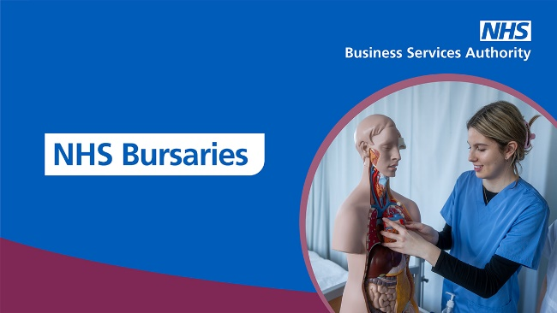
Instagram | The NHS Bursary is here for you, because you’re there for us 💙  If you’re studying to become a doctor or dentist, you could be eligible for extra support to help you through your university journey.  You could get a tuition fee contribution, means and non-means tested grants, and additional allowances based on your circumstances.  For more info, search for NHS Bursary 🔍 | 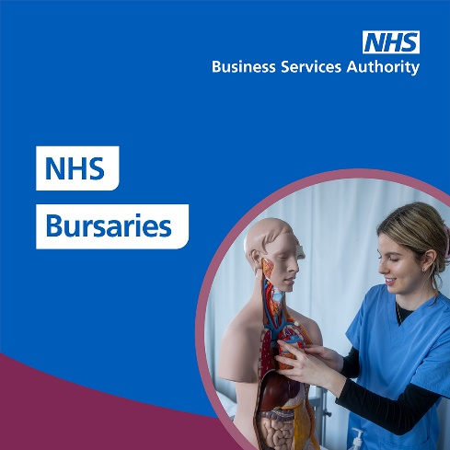

Travel
Facebook | ✈️ If you have a medical or dental placement overseas, you may be able to claim back costs for:  🔹 the travel costs between your term-time address and the airport or ferry terminal  🔹 accommodation costs  🔹 essential costs like medical insurance, tests and visa fees  Read the full details 👉 https://nhsbsa-live.powerappsportals.com/knowledgebase/article/KA-02351/en-us | 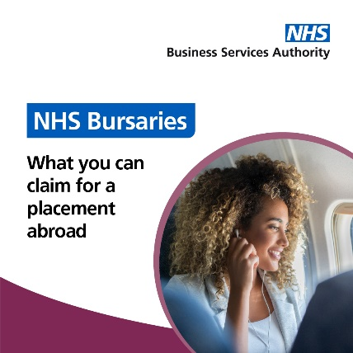
Facebook | If you have to stay somewhere, away from your usual term-time address, to attend your placement, you could claim back accommodation expenses 🏡🚌  Find out more about Travel and Dual Accommodation Expenses from NHS LSF 👉 https://www.nhsbsa.nhs.uk/nhs-learning-support-fund-lsf/travel-and-dual-accommodation-expenses | 
X | If you have to stay somewhere, away from your usual term-time address, to attend your placement, you could claim back accommodation expenses 🏡🚌  Find out more about Travel and Dual Accommodation Expenses from #NHSLSF 👉 https://www.nhsbsa.nhs.uk/nhs-learning-support-fund-lsf/travel-and-dual-accommodation-expenses | 
X | Sometimes, attending your clinical placement might mean extra travelling – or even overnight stays 🚗  But did you know, you can claim back expenses through #NHSLSF? Find out more on their website 👉 https://www.nhsbsa.nhs.uk/nhs-learning-support-fund-lsf/travel-and-dual-accommodation-expenses | 

